**Company directory test document**

**By Fahim Hasan**

**View data tests**

1. The user can see all the employees, departments and locations currently in the database by clicking the items in the nav bar.

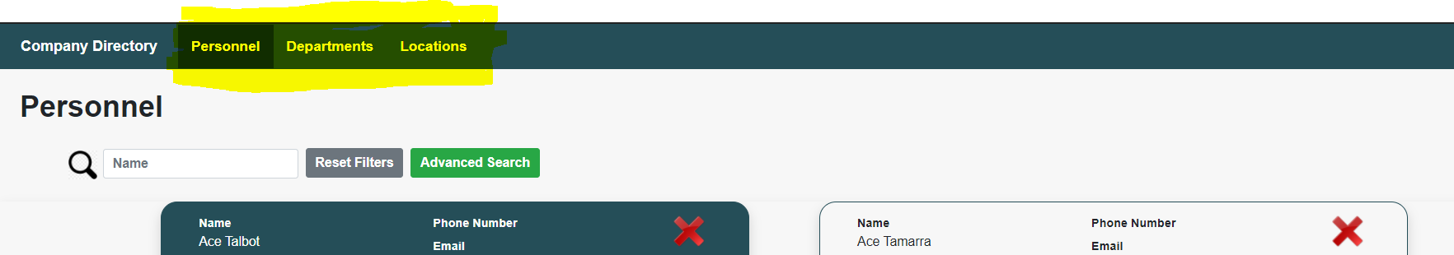

Test outcome 

1. The user can filter by name the employees, departments and locations.

Test outcome 

1. The user can filter the employees using the advanced search feature, by clicking the advanced search button a modal will appear where the user will be able to filter the employees by name, department and location.

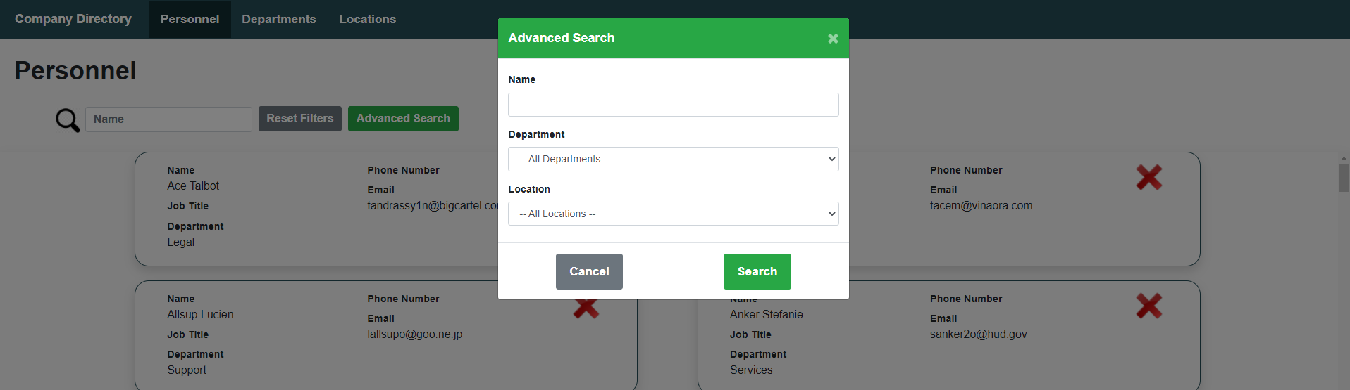

Test outcome 

1. Once the user applied some advanced search filters on the employees, he can reset this filters by clicking the reset filters button.

Test outcome 

**Insert new data tests**

1. The user will be able to insert a new employee by clicking the add employee button, then this modal will be displayed.

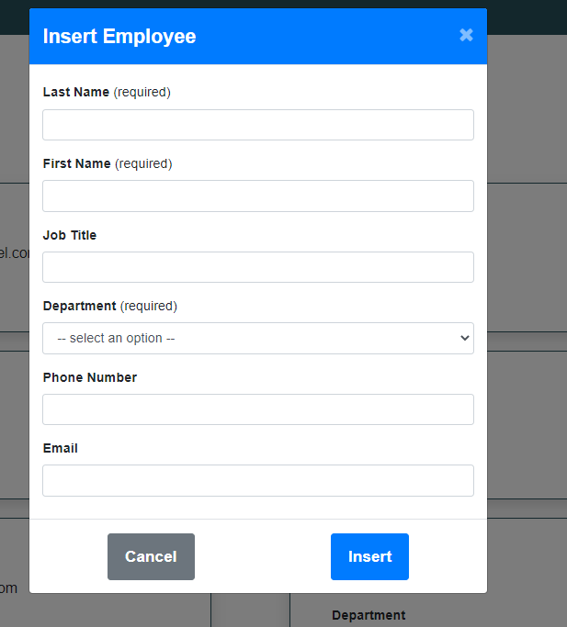

Last Name, First Name and department are required and the new employee will not be inserted if this fields are not populated, instead some warning messages will be displayed.

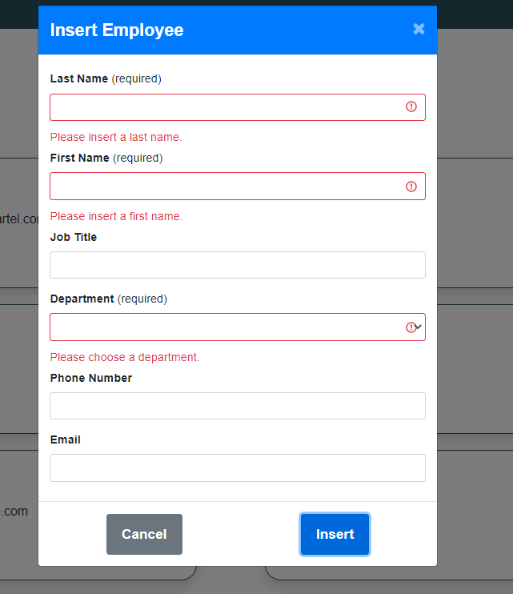

Test outcome 

1. The user will be able to insert a new department by clicking the add department button, then this modal will be displayed.

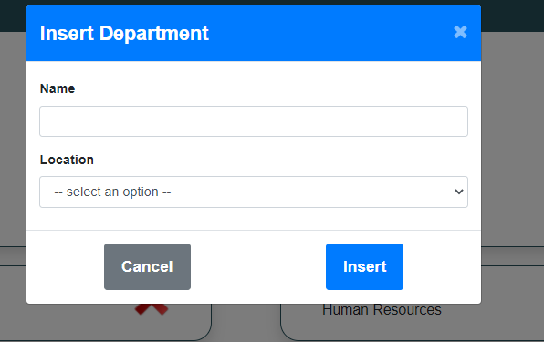

Both fields are required and the department will not be inserted if this fields are not populated.

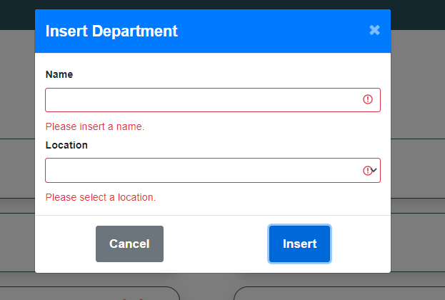

Test outcome 

1. The user will be able to insert a new location by clicking the add location button, then this modal will be displayed.

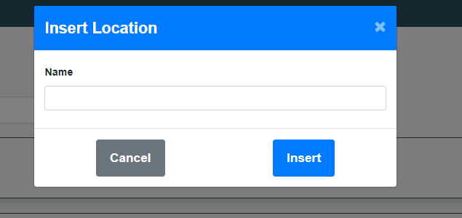

The field name is required and the location will not be inserted if it’s not populated.

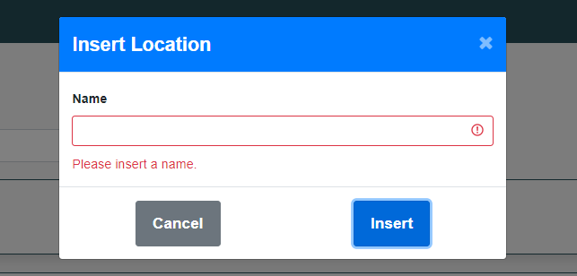

Test outcome 

**Edit data tests**

1. The user will be able to edit any employee displayed in the table by simply clicking in the employee box.

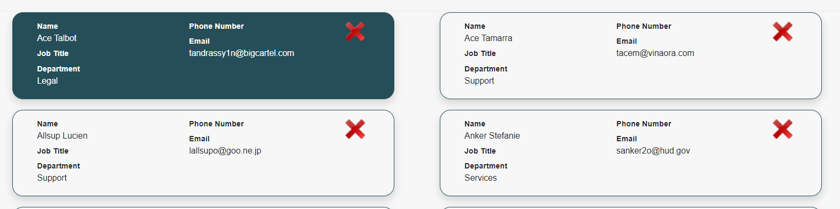

Then this modal will be displayed with the data of the employee selected.

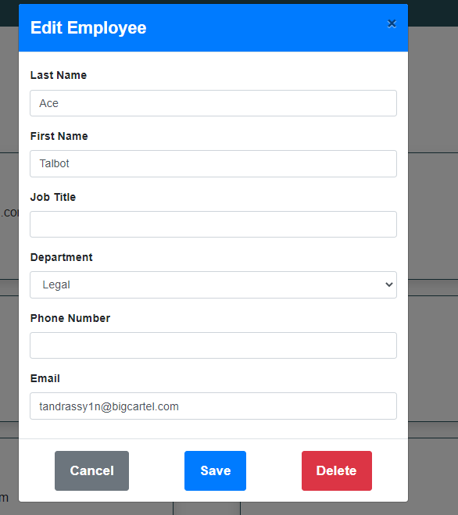

The user will be able to change any field and save the employee data.

The fields last name and first name are required if this fields are not populated the user will not be able to edit the employee instead some warning messages will be displayed.

Test outcome 

1. The user will be able to edit any department displayed in the table by clicking on the department box, then a modal will appear with the selected department data where the user will be able to modify the values and save.

The field name in this modal is required and the department will not be edited unless this field is populated, instead a warning message will be displayed.

Test outcome 

1. The user will be able to edit any location displayed in the table by clicking on the location box, then a modal will appear with the selected location data where the user will be able to modify the values and save.

The field name in this modal is required and the location will not be edited unless this field is populated, instead a warning message will be displayed.

Test outcome 

**Delete data tests**

The user will be able to delete any employee, department and location by clicking the delete icon inside each box.

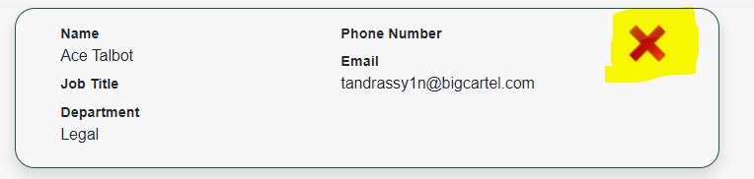

Then this modal will be displayed to confirm the delete.

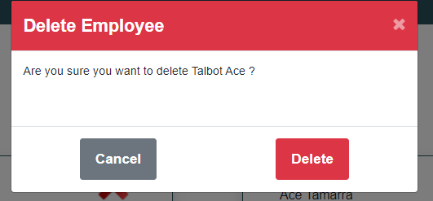

The user will also be able to delete employees, departments and locations from their edit modals.

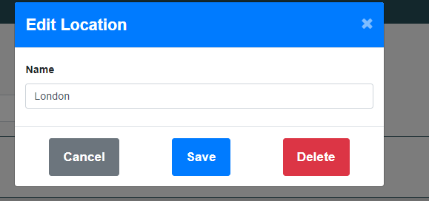

By pressing the delete button here, the confirm delete modal will be displayed to confirm the delete.

Test outcome 

10/15/2020 Signature

…………………………………………………